Helm Deep Dive V3:

https://linuxacademy.com/cp/courses/lesson/course/8472/lesson/1/module/814

package manager for K8s.multiple applications and their dependencies can be managed in a single helm package.

Deploying to k8s without Helm:

Sample repo: https://github.com/linuxacademy/content-helm-deep-dive-v3.git

kubectl get nodes

kubectl get sc

kubectl get pv

kubectl apply -f wpmysql.yaml

kubectl apply -f wp.yaml

kubectl get pods

kubectl get svc

kubectl delete -f wpmysql.yaml

kubectl delete -f wp.yaml

Deploying to k8s using Helm:

kubectl get sc 🡪 to check storage classes

kubectl get pv 🡪to check persistent volumes

helm repo update

helm install demowp stable/wordpress 🡪 it will show output with post configuration steps.

kubectl get pods

helm ls 🡪shows all releases

helm delete demowp

**Installing Helm**:

Prereq: k8s and kubectl configured.

Manual process:

curl -fsSL -o helm.tar.gz https://get.helm.sh/helm-v3.4.1-linux-amd64.tar.gz

tar -xzf helm.tar.gz

sudo mv ./linux-amd64/helm /usr/local/bin/

helm version

helm repo add stable https://charts.helm.sh/stable

helm repo update

helm search repo wordpress

helm install demowp stable/wordpress

helm ls

helm delete demowp

Using scripts:

curl -fsSL -o get-helm.sh <https://raw.githubusercontent.com/helm/helm/master/scripts/get-helm-3>

helm repo list

helm fetch stable/Jenkins

helm fetch stable/spark

#these will download tar files current directory

Helm repo index ./example/

Ls -l ./example/

cat ./example/index.yaml 🡪 description the charts available.

Add above example folder to github.and served it in github pages.

helm repo add custom_name <https://darealmc.github.io/>

helm repo remove stable🡪default repo

help repo update

helm search repo spark

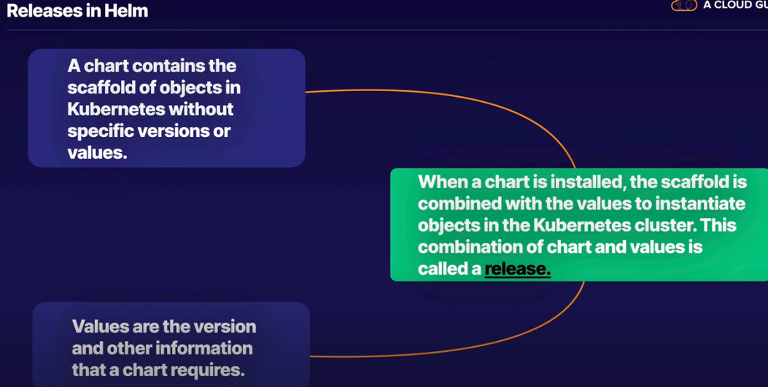

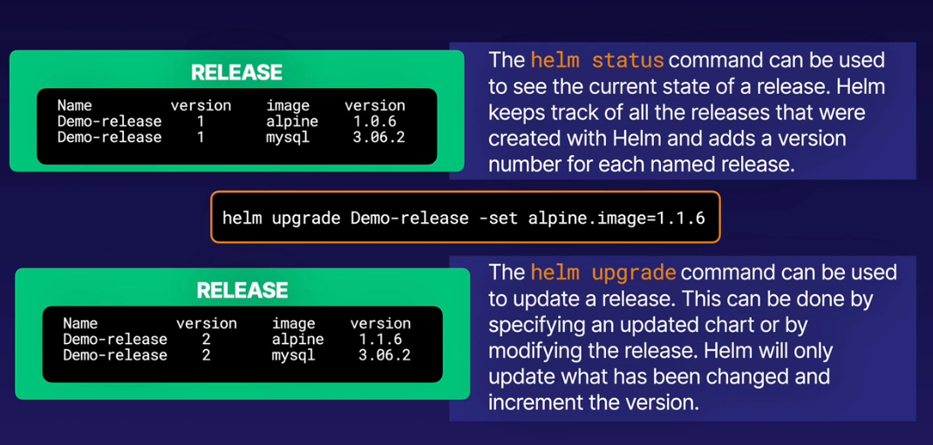

helm install example ./ngin

cat ./ngin/Chart.yaml

kubectl get po

helm upgrade example ./ngin –set image.tag=’alpine’

current: <https://linuxacademy.com/cp/modules/view/id/814>